**Question 1**

1. Add a 10GB disk to the CentOS.

2. Create 2 Partitions 4GB and 6GB of Space respectively.

3. Format 4GB with xfs and 6GB with ext4 file system.

4. Mount 4GB and 6GB in /data and /music directory respectively.

5. Create one file of 1GB in each of the mount point created above.

6. Verify the disk Consumption and disk space free in the mounted partitions.

**Step 1:** Add a 10GB disk to the CentOS

**Screenshot 1:**

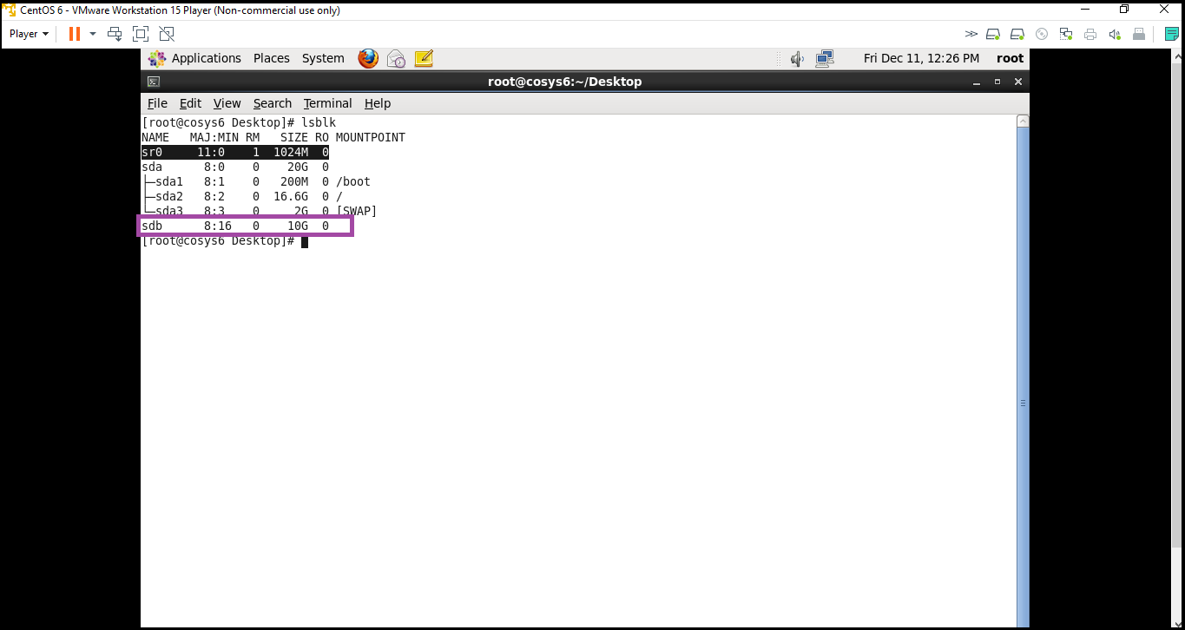

**Step 2:** Create 2 Partitions 4GB and 6GB of Space respectively.

**Screenshot 1:**

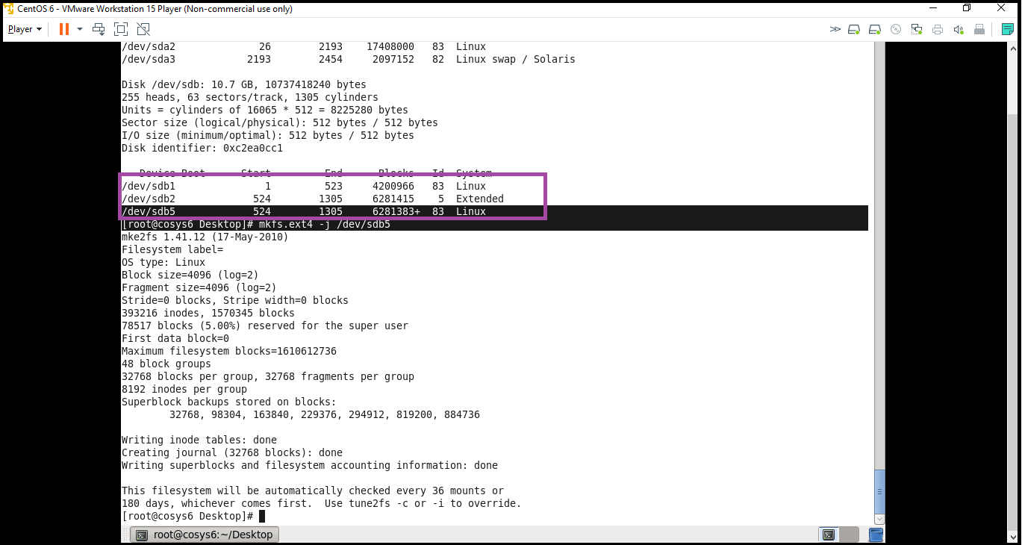

**Step 3:** Format 4GB with xfs and 6GB with ext4 file system.

**Screenshot 1:**

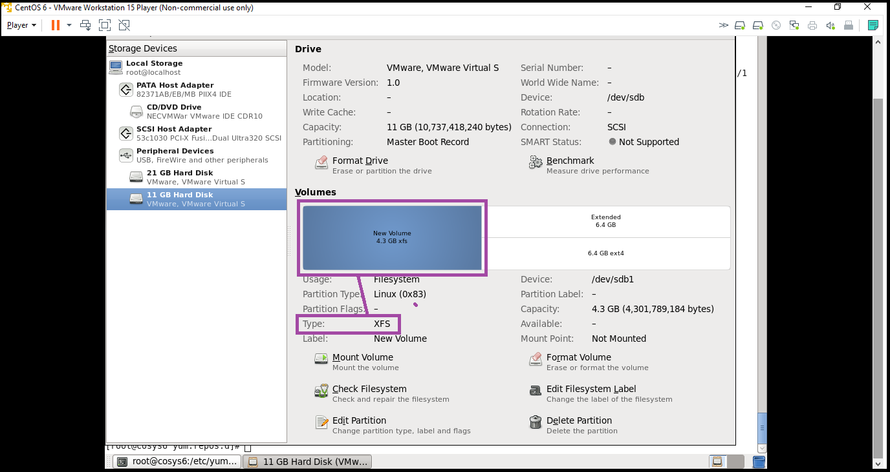

**Screenshot 2:**

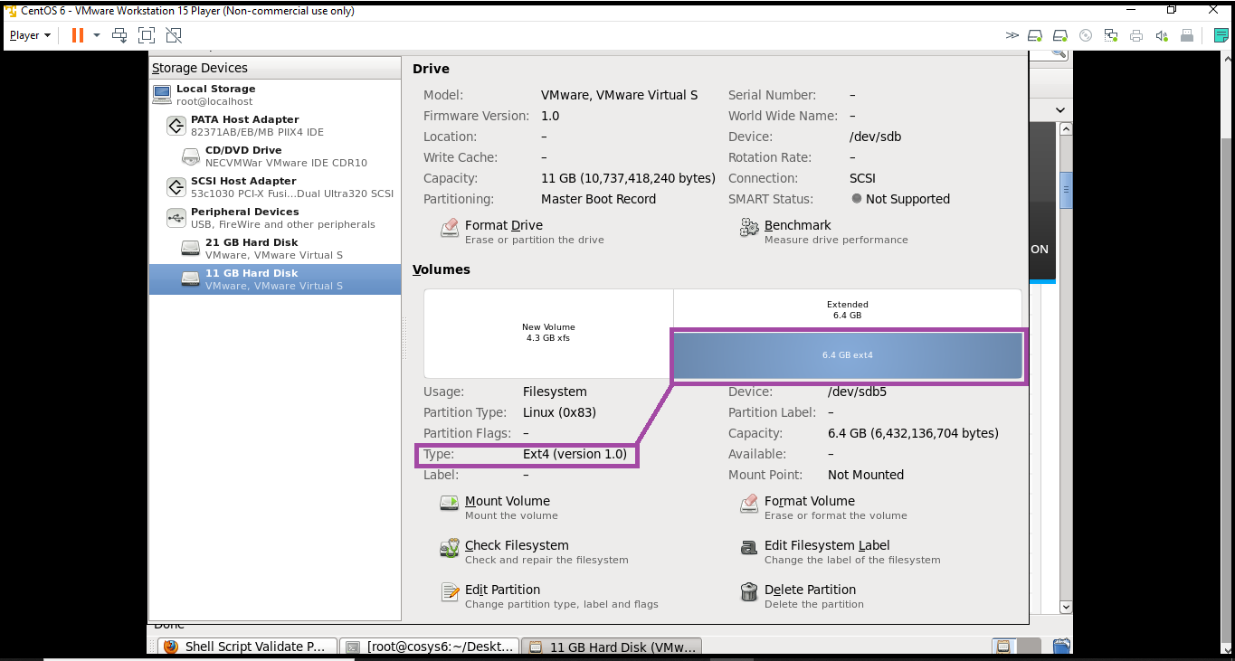

**Step 4:** Mount 4GB and 6GB in /data1 and /music1 directory respectively.

**Screenshot 1:**

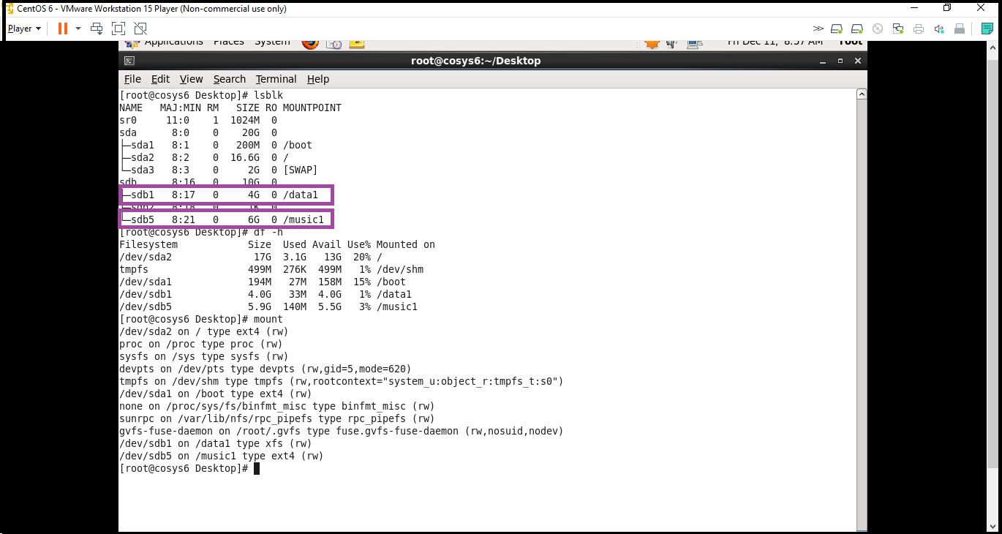

**Step 5:** Create one file of 1GB in each of the mount point created above

**Screenshot 1:**

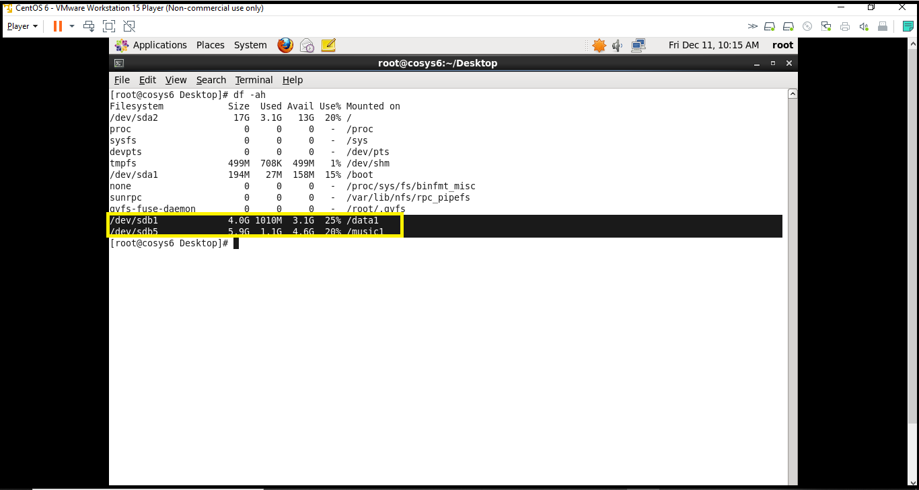

**Step 6:** Verify the disk Consumption and disk space free in the mounted partitions

**Screenshot 1:**

